Module 4

1. what is super global arrays? List and explain.

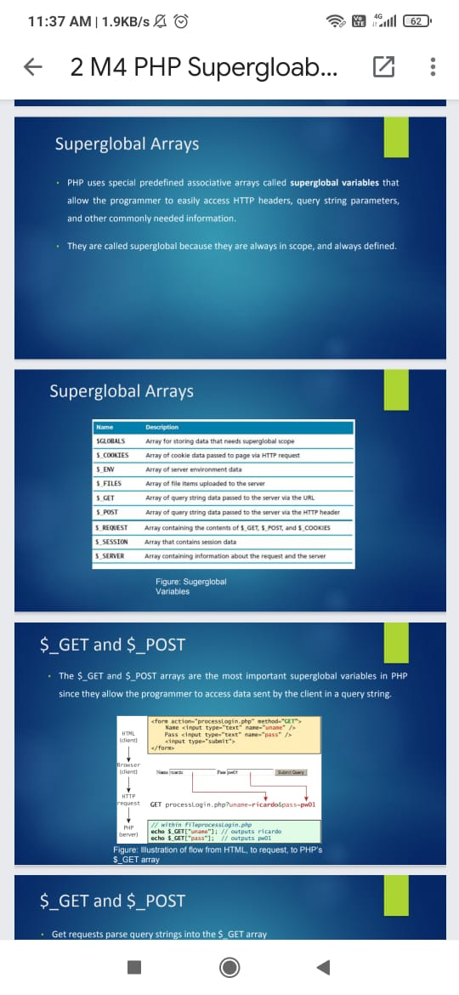

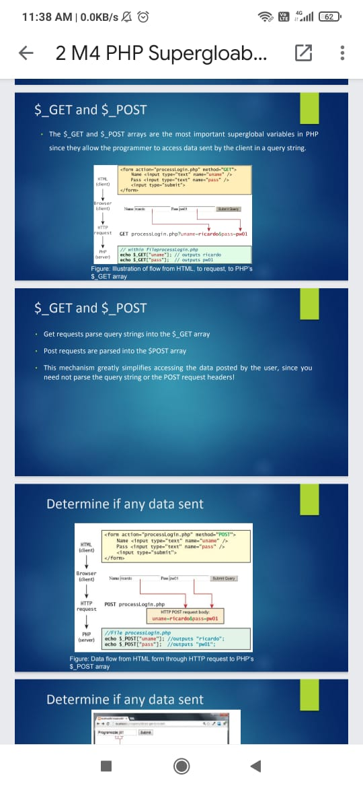

1. Define constructor and discuss the concepts of inheritance,polymorphism and object interface wrt OOPS

A Constructor is a special type of subroutine called to create an object. It prepares the new object for use, often accepting arguments that the constructor uses to set required member variables.

Inheritance: Inheritance enables you to create new PHP classes that reuse,

extend, and modify the behavior that is defined in another

PHP class.

• PHP only allows you to inherit from one class at a time

• A class that is inheriting from another class is said to be a

subclass or a derived class

• The class that is being inherited from is typically called a

superclass or a base class

A PHP class is defined as a subclass by using the extends

keyword.

class Painting extends Art { . . . }

$p = new Painting();

. . .

echo $p->getName(); // defined in base class

echo $p->getMedium(); // defined in subclass

Polymorphism: Polymorphism is the notion that an object can in fact be multiple things at the same time.

Consider an instance of a Painting object named $guernica created as

follows:

$guernica = new Painting("1937",$picasso,"Guernica","Oil on canvas");

The variable $guernica is both a Painting object and an Art object due to

its inheritance.

The advantage of polymorphism is that we can manage a list of Art

objects, and call the same overridden method on each.

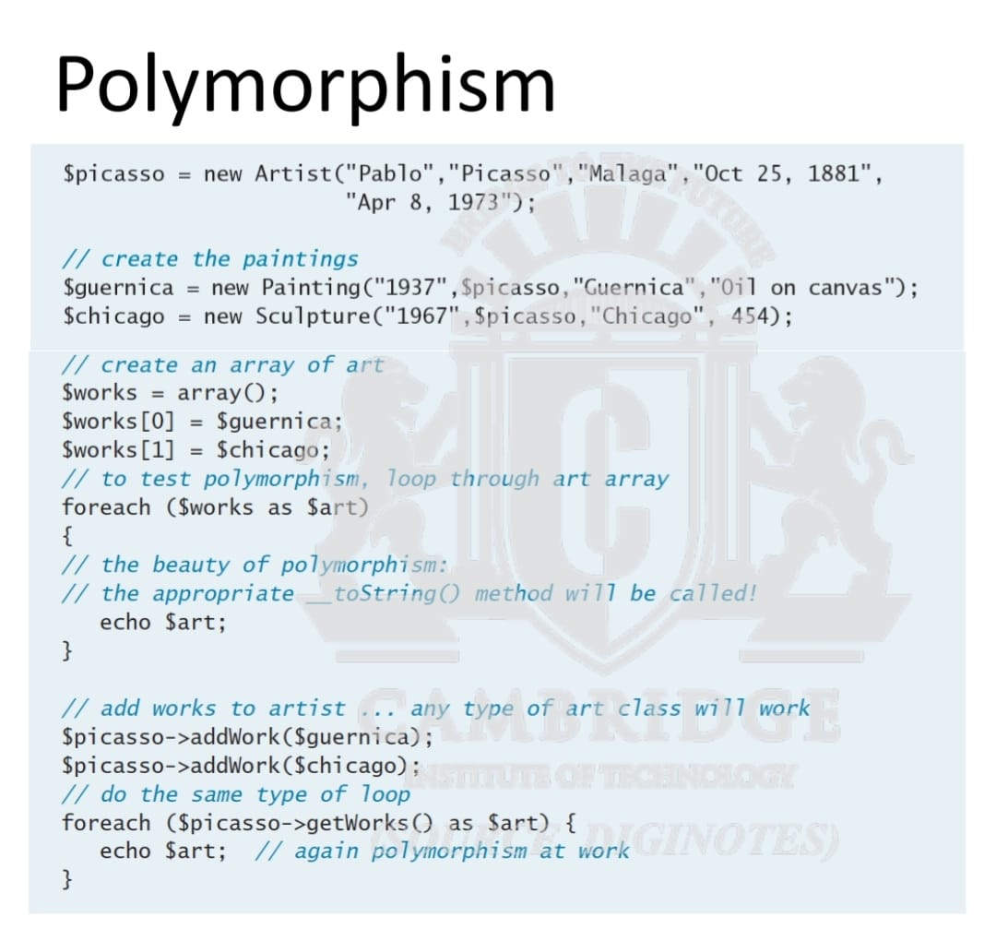

Object Interface:

An object interface is a way of defining a formal list of

methods that a class must implement without specifying their

implementation. Interfaces are defined using the interface keyword, and look similar to standard PHP classes, except an interface contains

no properties and its methods do not have method bodies

defined.

interface Viewable {

public function getSize();

public function getPNG();

}

In PHP, a class can be said to implement an interface,

using the implements keyword:

class Painting extends Art implements Viewable { ... }

This means then that the class Painting must provide

implementations for the getSize() and getPNG() methods.

3.Explain with example the two basic technic for read/write files in php 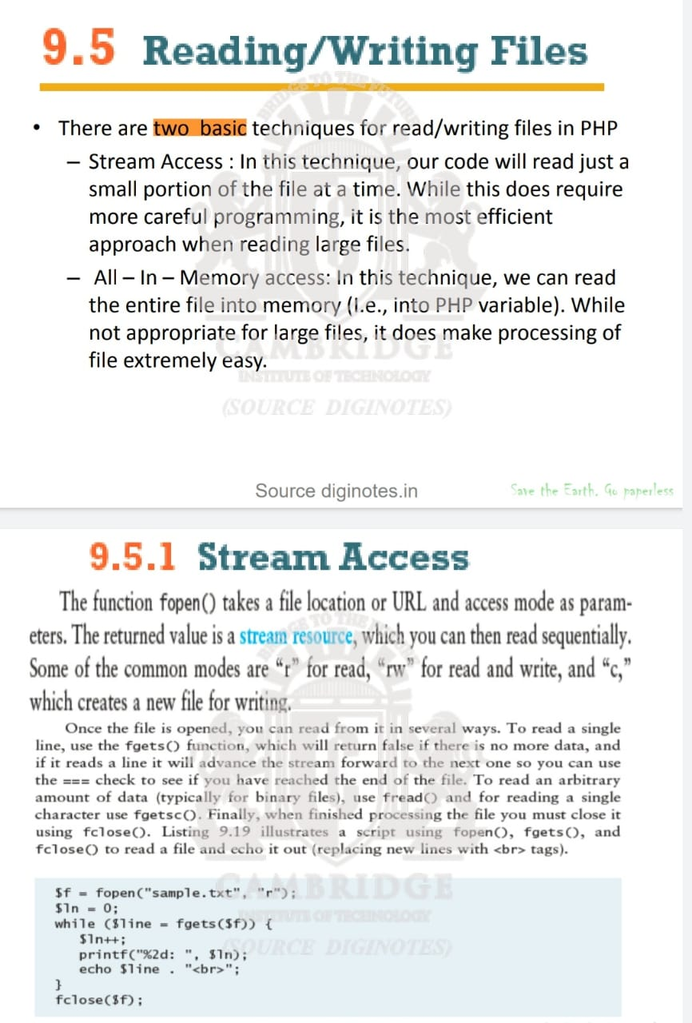

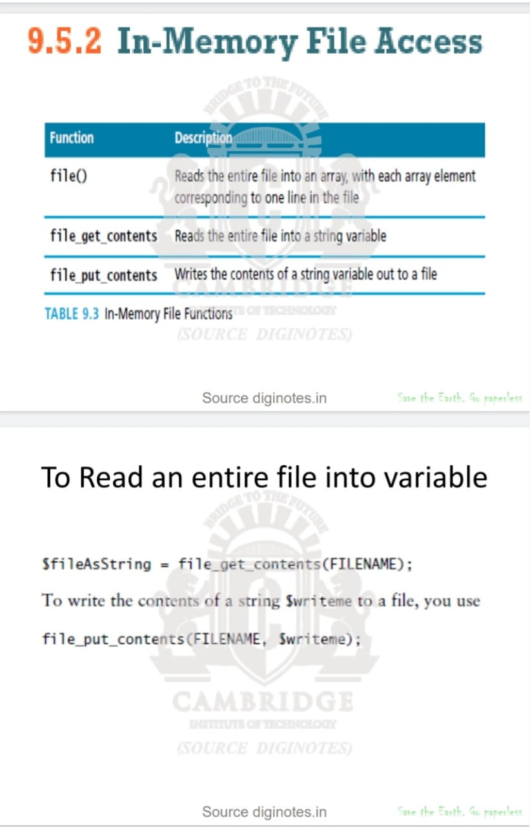

4.Write the php code to validate phone number

5.With the data flow diagram explain the role of PHP’s $_GET and $_POST arrays.

6.Explain procedural error handling and object oriented exception handling with suitable code segment

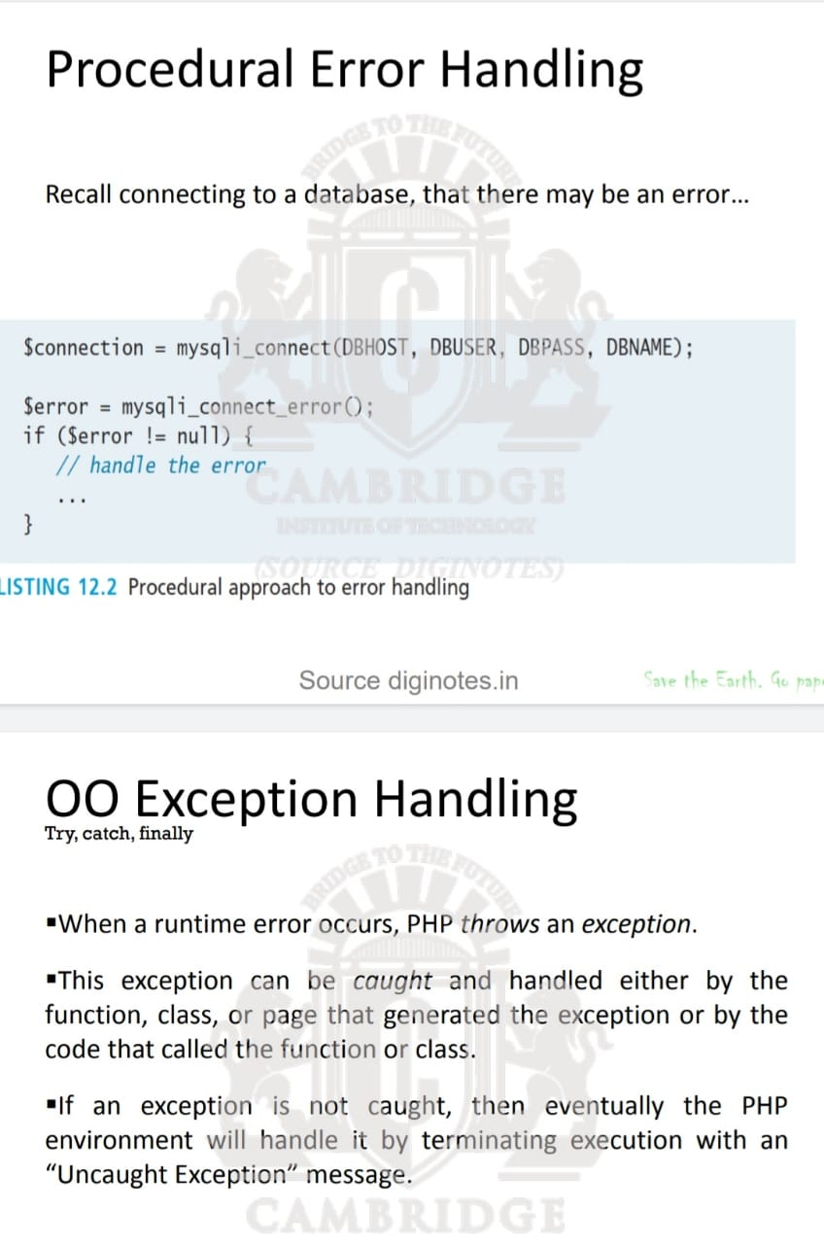

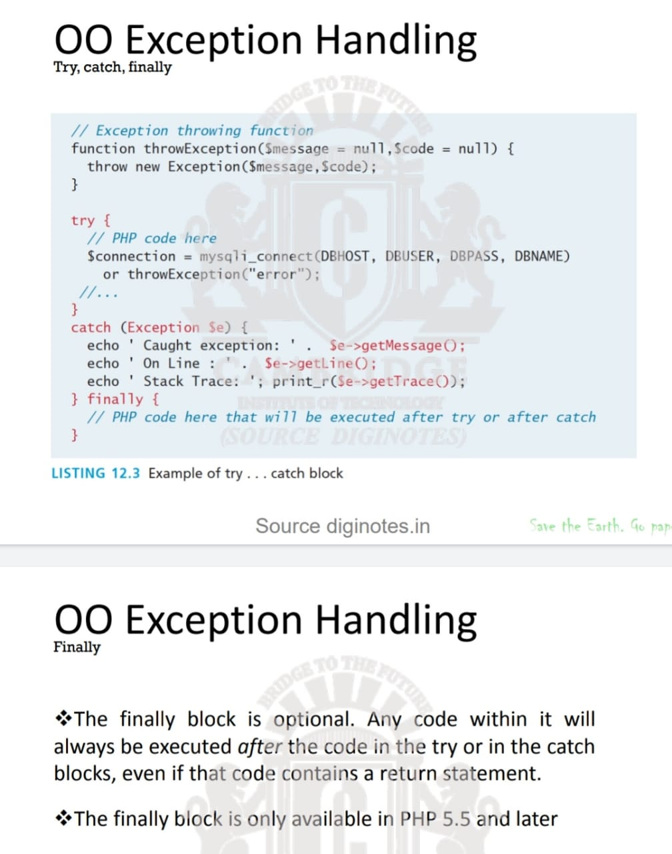

7.Explain the support for inheritance in php with UML class diagram

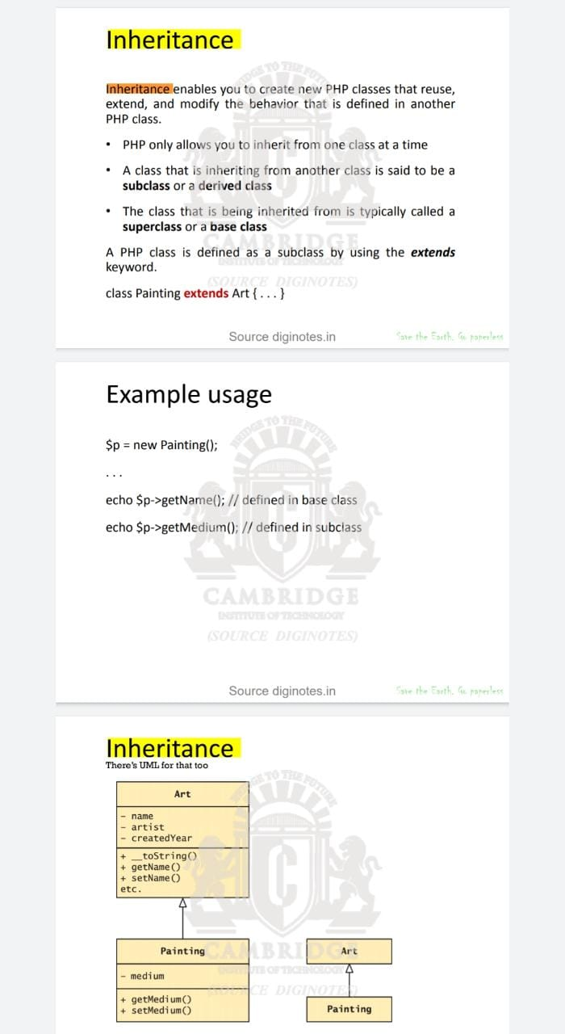

8.Explain 3 approaches to restrict the file size in file upload with suitable code segment

There are three main mechanisms for

maintaining uploaded file size restrictions:

– Via HTML in the input form

– Via JavaScript in the input form

– Via PHP coding.

9.Explain $_GET and $_POST supergoals arrays

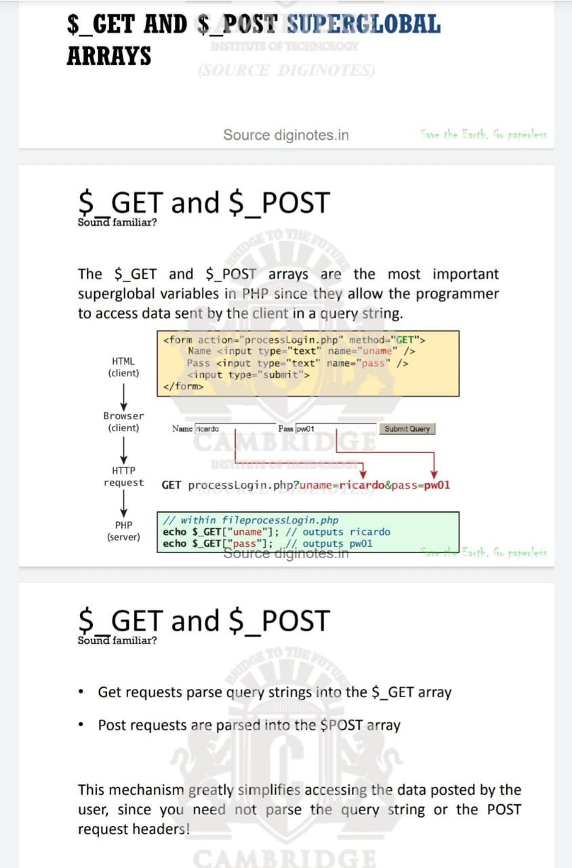

10. how do you achieve data encapsulation in php? Give example.

